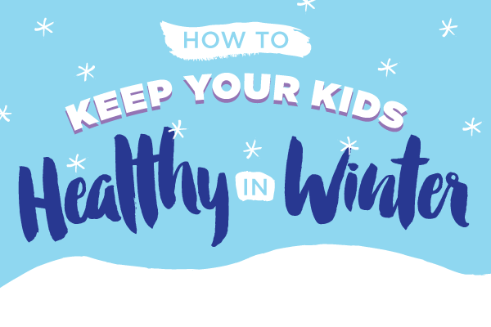

Sleep
Sleep is so important, it is one of the things that gives your child the energy they need to get through the day - to run, jump, play, make new friends and have fun.
“But I’m not tired……”
Without enough sleep they can struggle to concentrate, can feel cross and short tempered, over emotional, or want to crash out and lie down – when everyone else is busy getting on and having fun. Sleep rules!
Everyone needs a different amount of sleep and this changes as they grow up, but as a guide if your child is in primary school they should be getting 10-11 hours’ sleep a night, so probably going to bed between 7 and 8 every night.

Get them active
Encouraging your children to lead an active lifestyle now can create lifelong healthy habits and attitudes. Incorporate regular physical activity into your family's routine. A morning stretch before breakfast can be a way to start, and you can plan different activities for different days. Find creative ways to stay active even when you’re stuck at home--turn on some music and dance. It might not sound appealing to spend time outside during the coldest months, but if you wrap up well it can be fun.

Hand washing
It goes without saying that our hands are the biggest source of germs in everyday situations, especially when runny noses and coughing are at their peak during cold months. Make sure your kids know the “cough into your arm” trick, but teach them that it’s still important to wash their hands after contact with others or after they use a tissue to wipe their nose. Make it routine, and your kids will begin to do it without thinking. Before and after eating, as soon as they get home from school, after playing with a friend, and after using the bathroom, remind them to use soap.

Diet
To stay fit and healthy throughout life it is really important that we eat a balanced diet every day.
Make sure your child/ren are putting the right food into their body to give them enough energy and to give their body the correct nutrients to keep them fit and healthy. If you want a guide on balanced diets, these are available in the office.

Don’t forget fluids
Healthy foods are one way to keep your family healthy, but it’s important not to forget fluids. Keep your children well hydrated, especially while they’re playing outside, and steer clear of sugary drinks, juices, and flavoured drinks. Plain old water is the best way to go. kids should be drinking about 6 glasses a day. Have them use a fun water bottle to keep track of their hydration.

