School Uniform

As we approach a new school year here at Greenmount we wanted to remind parent and carers of our expectations when it comes to school uniform. As you will agree the children look very smart when wearing a uniform and this also saves their own home clothing from getting ruined.

Girls
- Navy Blue Round Neck Jumper
- Navy Blue Cardigan
- White Polo Shirt
- Grey Trousers/Skirt/Pinafore/shorts
- Grey or Navy Salwar Kameez
- Navy Blue Headscarf
- Navy Blue gingham checked summer dress
- Plain Black shoes

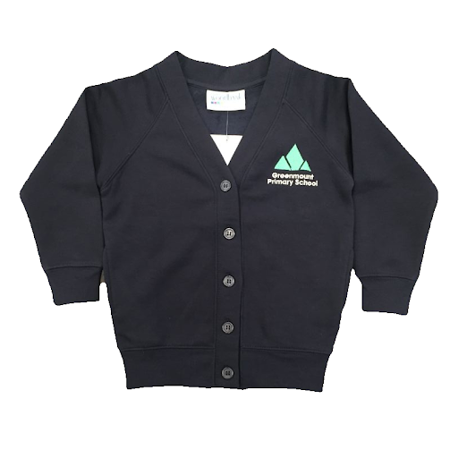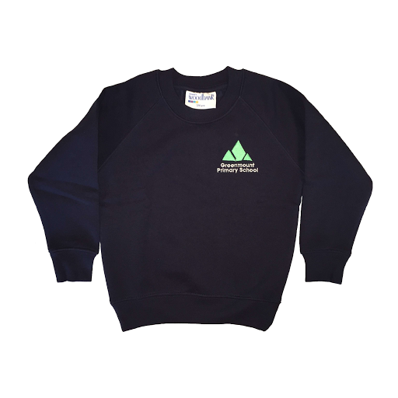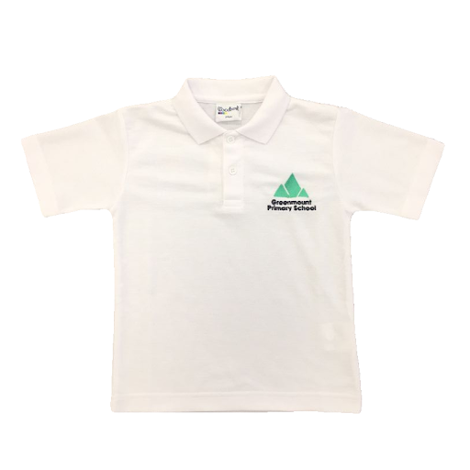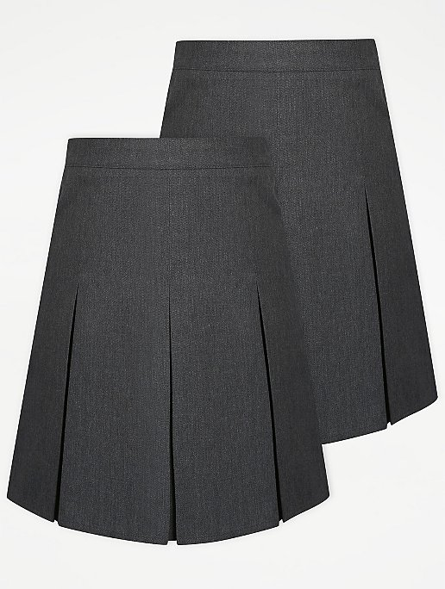
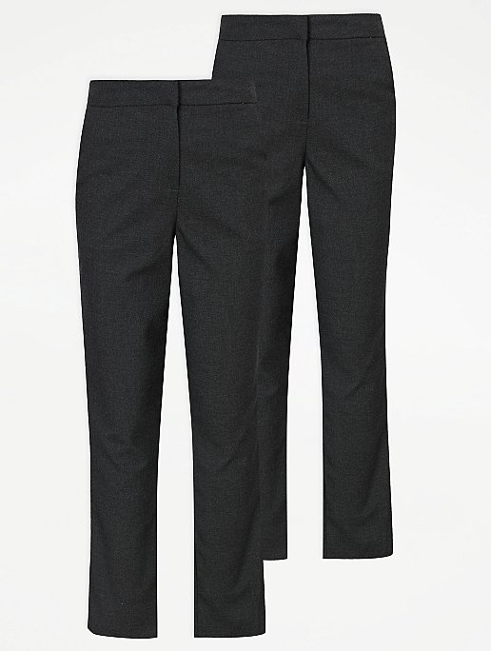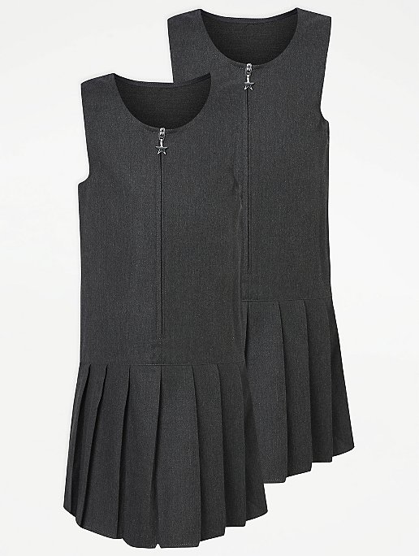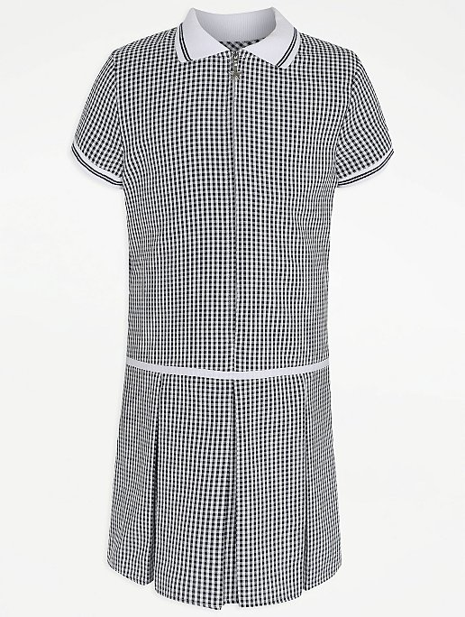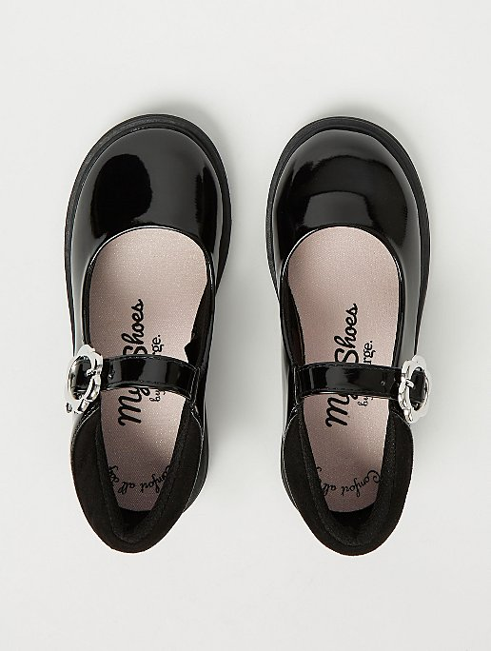
Boys
- Navy Blue Round Neck Jumper
- White Polo Shirt
- Grey Trousers/Shorts
- Plain Black shoes

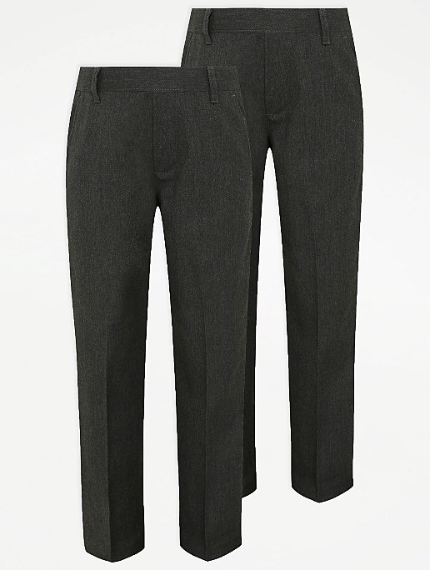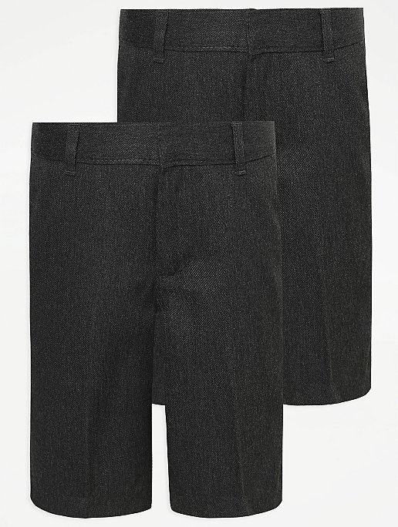
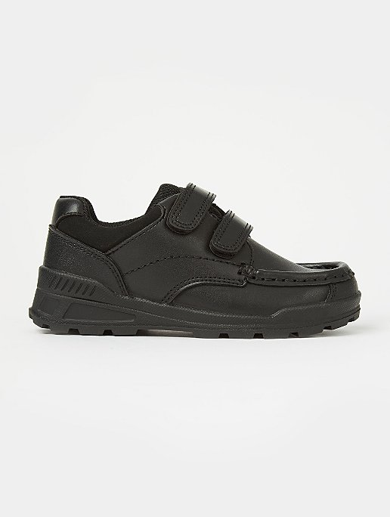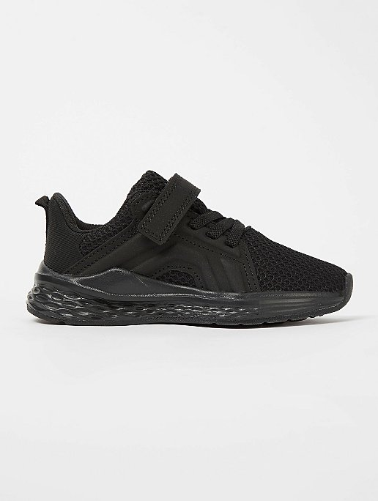

Jumpers, cardigans and polo shirts will be available to purchase from Design School Uniform with the Greenmount logo on or you can buy the plain ones which are widely available from lots of local supermarkets and retailers.

P.E Kit
We are introducing a PE kit this year and our expectation is that all children will have the required kit rather than coming to school in name brands such as Nike, Adidas etc. The PE garments are listed below:

- White polo t-shirt (Short or long sleeved)
- Jade Green Hoodie with Logo (only available at Design School Uniform)
- Black jogging bottoms/leggings or shorts
- Black Trainers or pumps

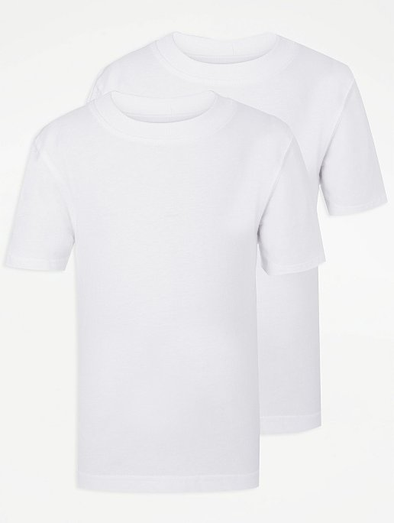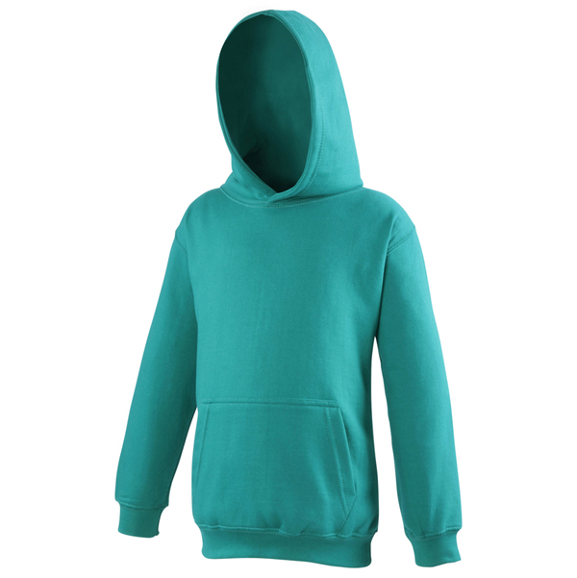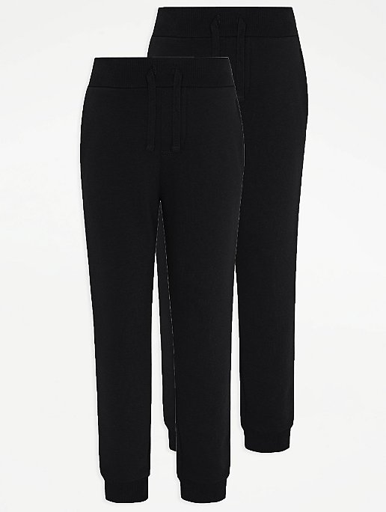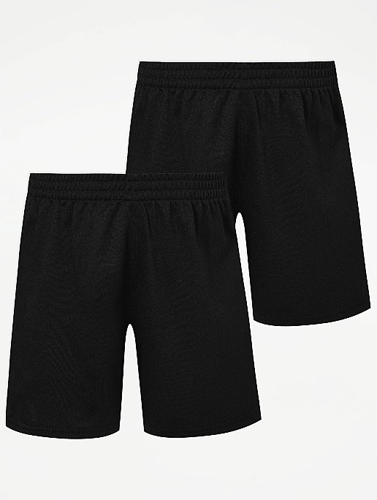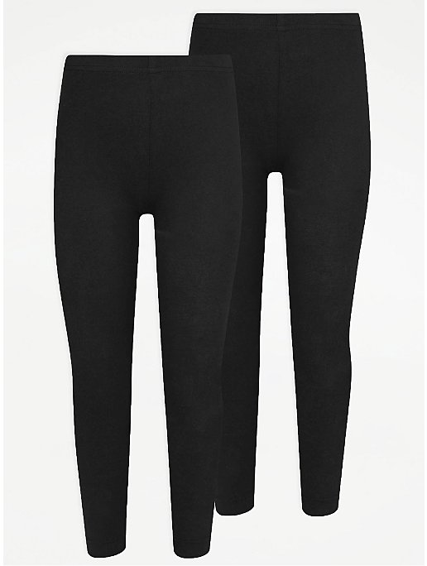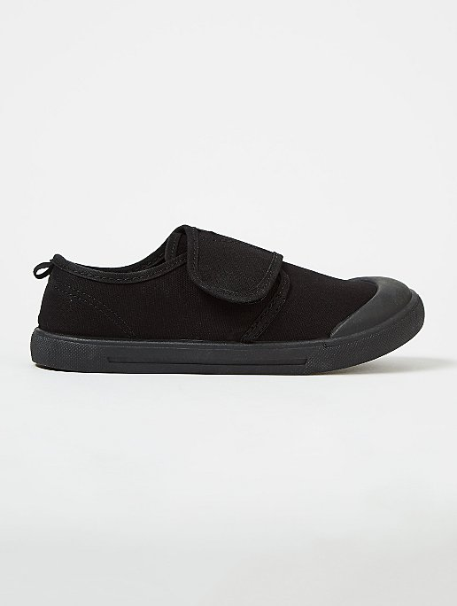

We will no longer be selling school uniform in school but if you want to buy uniform with a logo on they will be available from http://www.designschooluniform.co.uk/ they have a whole range of basic uniform to buy including trousers, dresses, skirts black pumps and bookbags with logo on. You can buy online or in store from Design School Uniform, 21-23 The Headrow, Leeds, LS1 6PU, 0113 2436642

*10% OFF ON ALL ORDERS IN JULY 2021 WITH CODE: summer2021

